**COA LAB**

**Experiment – 4**

**Problem Statement:** Write an assembly language program to check whether a given number is odd or even.

**Algorithm:**

1. Define the Base Register Address value during the creation of the program
2. Move the operand to the Register R1
3. Move the Register R1 value to the R0
4. Perform bitwise and operation on R1value and decimal number 1
5. Compare whether the resulting value is zero
6. If the resulting value is zero, jump to the Even label, set the Register R4 to 1 and exit
7. If the resulting value is not zero, jump to the Odd label, set the Register R5 to 1 and exit

**Assembly Language code:**

**MOV #37, R01** *//Store value of 37 in register R01*

**MOV R01, R00** *//Move register R01 value to R00.*

**AND #1, R01** *//AND Operation on R1 value and decimal number 1*

**CMP #0, R01** *//Compare register R01 value by 0*

**JEQ $EVEN** *//If register R01 value is equal to 0, jump to the 'EVEN' label*

**JNE $ODD** *//If the register R01 value is not equal to 0, jump to the 'ODD' label*

**EVEN:** *//Label for identifying even numbers*

**MOV #1, R04** *//Store value of 1 in register R04*

**HLT** *//Stop the simulator*

**EVEN:** *//Label for identifying odd numbers*

**MOV #1, R05** *//Store value of 1 in register R05*

**HLT** *//Stop the simulator*

**Result:**

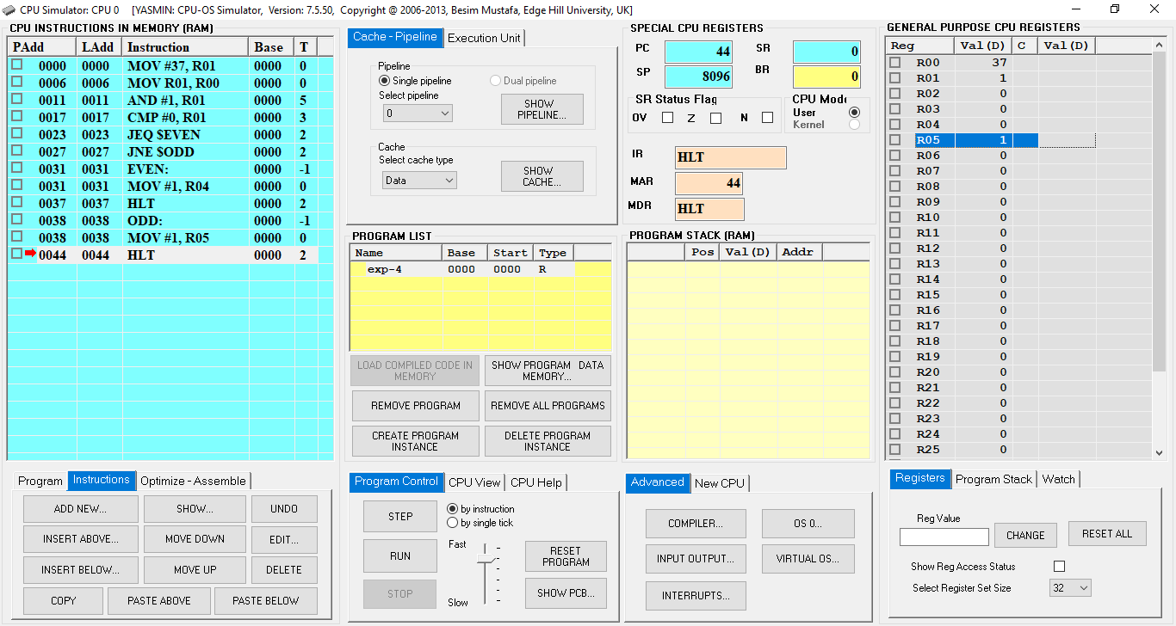**Case 1:** Odd

**Fig.1:** CPU Simulator Window

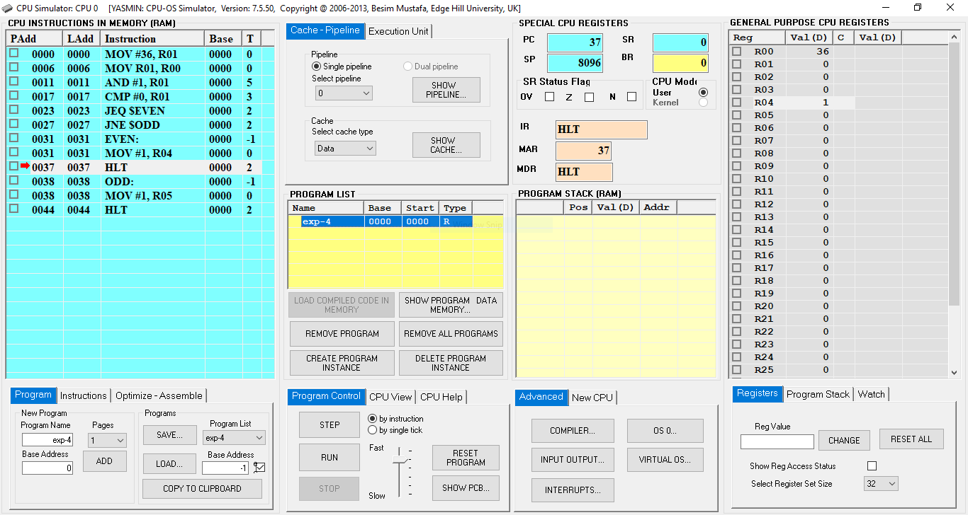**Case 2:** Even

**Fig.2:** CPU Simulator Window